**Phase 3: Data Modeling & Relationships**

**Standard Objects Used**

* **User** → Represents NGO staff, donors (if given portal access), and admins.
* **Campaign** → Used to manage fundraising initiatives (e.g., Education Drive, Healthcare Relief).
* **Contact (extended for Donors)** → Acts as the base for donor information, extended with custom fields.

**Custom Objects Created**

1. **Donor**
   * Stores additional donor details beyond Contact.
   * Key Fields: Donor ID (Auto-Number), Loyalty Points, Preferred Cause, Total Contributions, Badge Status.
2. **Donation**
   * Tracks all individual donations.
   * Key Fields: Donation ID, Amount, Date, Mode of Payment, Status (Pending/Completed/Failed).
   * Relationships: Linked to Donor, Campaign, and Beneficiary.
3. **Beneficiary**
   * Represents individuals or communities supported.
   * Key Fields: Beneficiary ID, Name, Type (Individual/Community), Support Details, Success Story.
4. **Donor Badge**
   * Tracks gamification & recognition.
   * Key Fields: Badge ID, Badge Type (Bronze/Silver/Gold), Earned Date.
5. **Impact Cart**
   * Mimics a shopping cart for multi-campaign donations.
   * Key Fields: Cart ID, Selected Campaigns, Total Donation Value, Forecasted Impact.

**Fields Breakdown (Detailed)**

**Donor**

* Donor ID (Auto-Number)
* First Name (Text)
* Last Name (Text)
* Email (Email)
* Phone (Phone)
* Address (Text Area)
* Loyalty Points (Number)
* Total Contributions (Currency, Roll-up from Donations)
* Preferred Cause (Picklist: Education, Health, Disaster Relief, Other)
* Badge Status (Formula/Lookup from Donor Badge)

**Donation**

* Donation ID (Auto-Number)
* Donation Amount (Currency)
* Date (Date/Time)
* Mode of Payment (Picklist: UPI, Card, Bank Transfer, Cash, Others)
* Status (Picklist: Pending, Completed, Failed, Refunded)
* Donor (Lookup to Donor)
* Campaign (Master-Detail to Campaign)
* Beneficiary (Lookup to Beneficiary)

**Beneficiary**

* Beneficiary ID (Auto-Number)
* Name (Text)
* Type (Picklist: Individual, Community)
* Age (Number, optional if Individual)
* Location (Text)
* Support Details (Long Text Area)
* Success Story (Rich Text Area)

**Campaign (Extended)**

* Campaign Goal (Currency)
* Amount Raised (Currency, Roll-up from Donations)
* Start Date (Date)
* End Date (Date)
* Status (Picklist: Active, Completed, Cancelled)

**Donor Badge**

* Badge ID (Auto-Number)
* Badge Type (Picklist: Bronze, Silver, Gold, Platinum)
* Earned Date (Date)
* Donor (Master-Detail to Donor)

**Impact Cart**

* Cart ID (Auto-Number)
* Donor (Lookup to Donor)
* Selected Campaigns (Multi-Select Picklist or Junction Relationship)
* Total Donation Value (Currency, Calculated)
* Forecasted Impact (Formula/Rich Text Area)

**Record Types**

* **Donation** → One-Time vs Recurring
* **Campaign** → Education, Healthcare, Disaster Relief, CSR
* **Beneficiary** → Individual vs Community

**Page Layouts**

* **Donor Layout** → Personal info, donation history (related list), loyalty points, earned badges.
* **Donation Layout** → Donor, Campaign, Beneficiary, Amount, Status.
* **Campaign Layout** → Goal, Raised, Progress bar, Associated Donations.
* **Beneficiary Layout** → Details, Linked Donations, Linked Campaigns, Success Stories.
* **Donor Badge Layout** → Badge Type, Earned Date, Linked Donor.
* **Impact Cart Layout** → Selected Campaigns, Total Value, Forecasted Impact.

### Compact Layouts

* **Donor** → Name, Loyalty Points, Total Contributions, Badge Status.
* **Donation** → Amount, Status, Date.
* **Campaign** → Name, Goal, Raised, End Date.
* **Beneficiary** → Name, Type, Location, Support Status.

### Relationships (Detailed)

* **Donor → Donation** → Lookup (One donor can have many donations).
* **Campaign → Donation** → Master-Detail (Each donation must belong to a campaign).
* **Beneficiary → Donation** → Lookup (Donation linked to one beneficiary).
* **Donor → Donor Badge** → Master-Detail (Badges tied to donor lifecycle).
* **Donor → Impact Cart** → Lookup (Cart is linked to donor, can have multiple campaigns).

### Junction Objects

* **Donation** → Junction between Donor and Campaign.
* **Impact Cart** → Junction between Donor and multiple Campaigns.

### Schema Builder

* Used to visually design & verify relationships.
* Highlights:
  + Central object → **Donation**.
  + Donor ↔ Donation ↔ Campaign → core fundraising flow.
  + Beneficiary connected via lookup to Donation.
  + Gamification objects (Donor Badge, Impact Cart) extend donor engagement model.

### External Objects (Future Scope)

* **Payment Gateway Integration** → Stripe/PayPal/UPI external objects to pull transaction details.
* **Corporate CSR Systems** → Sync corporate donations to Salesforce campaigns.
* **Impact Story Repository** → External content (images, videos, testimonials) stored outside Salesforce but linked via External Objects.

### Screenshots:

### Donor Object

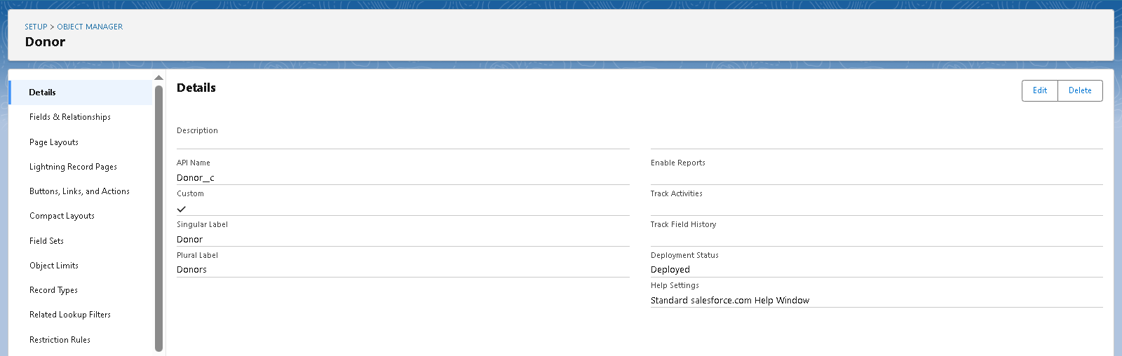 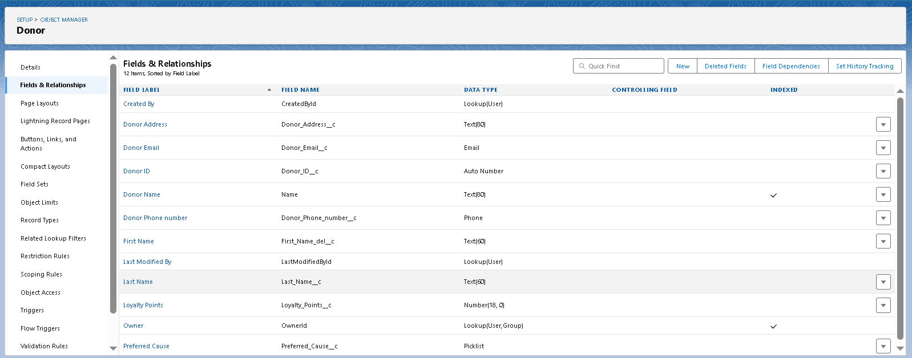

### Campaign Object

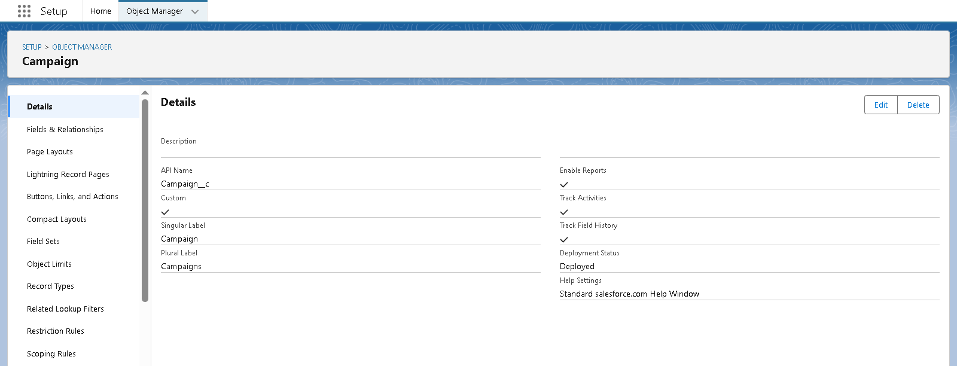

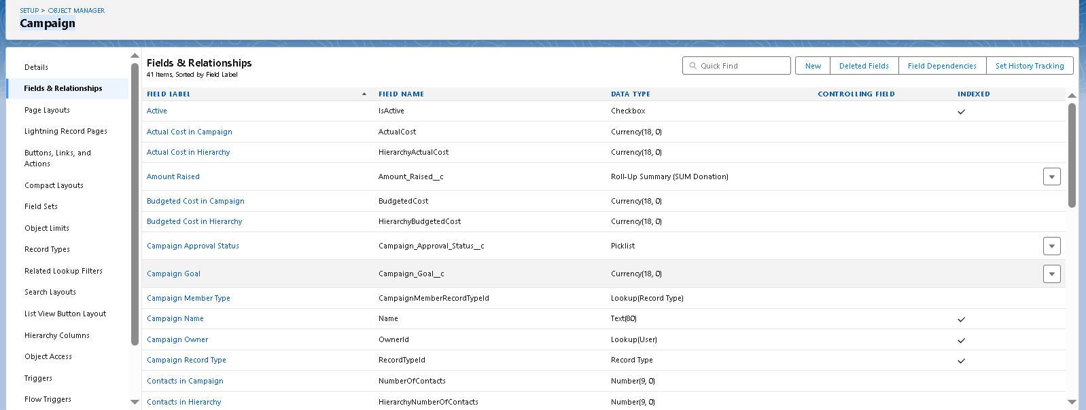 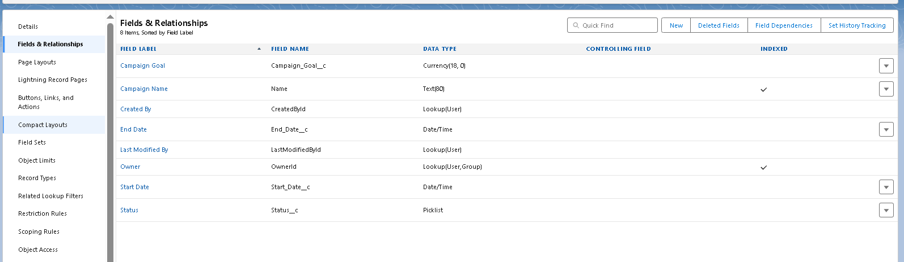

### Beneficiary Object

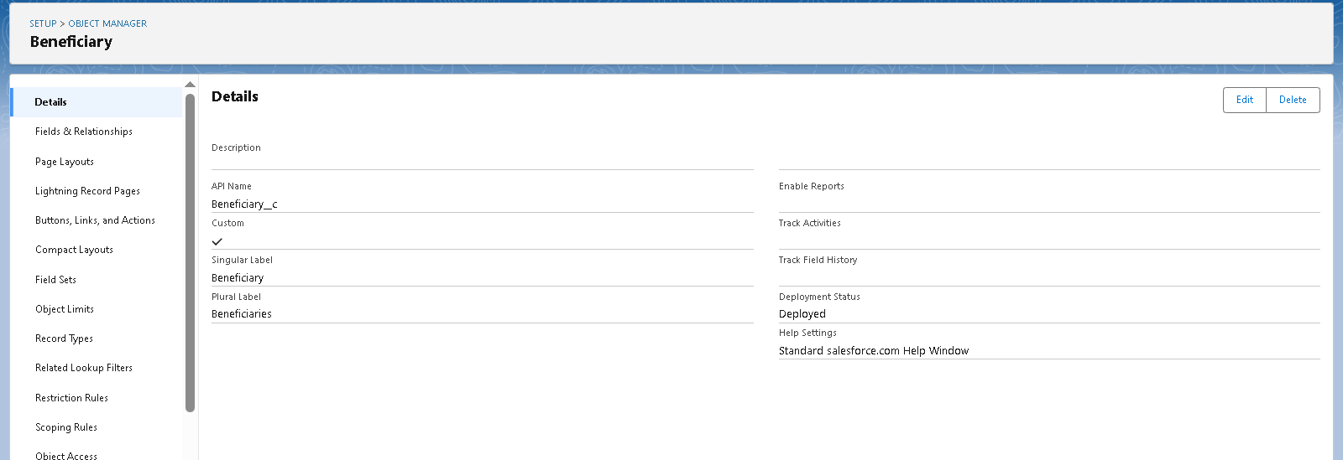

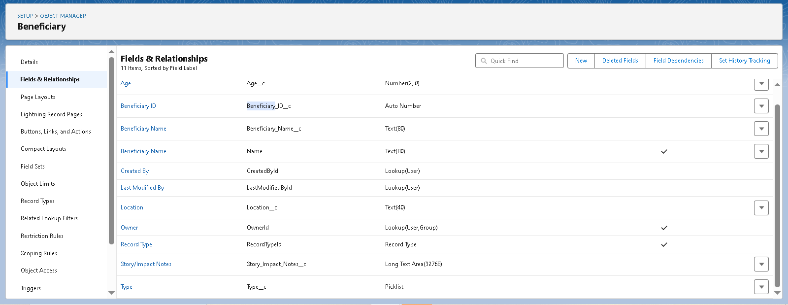

### Donation Object

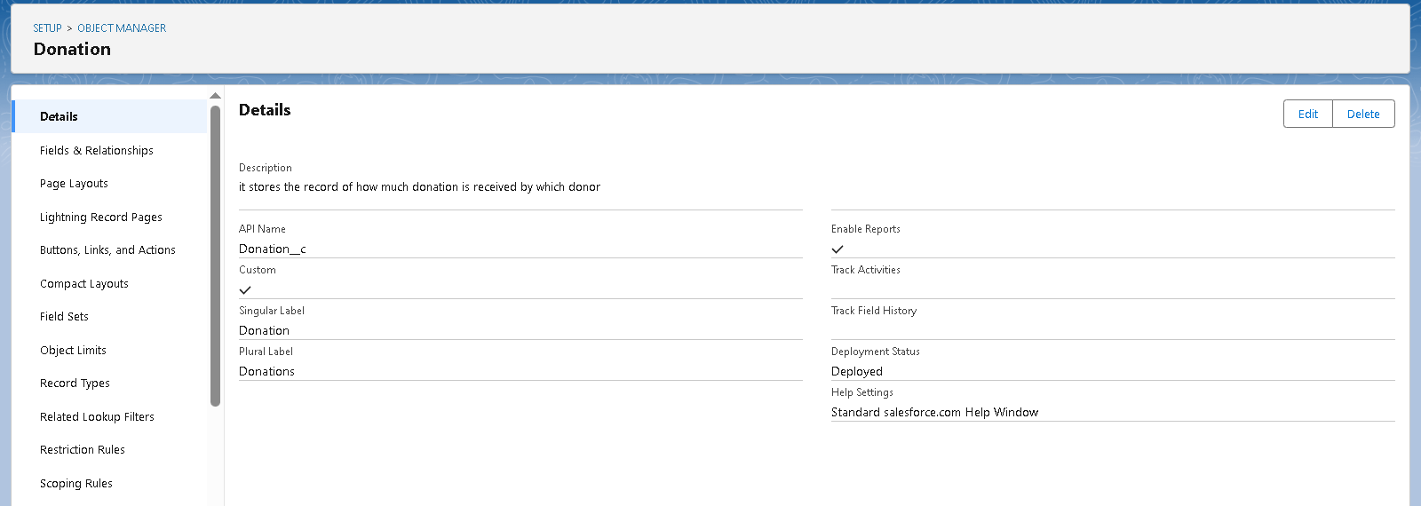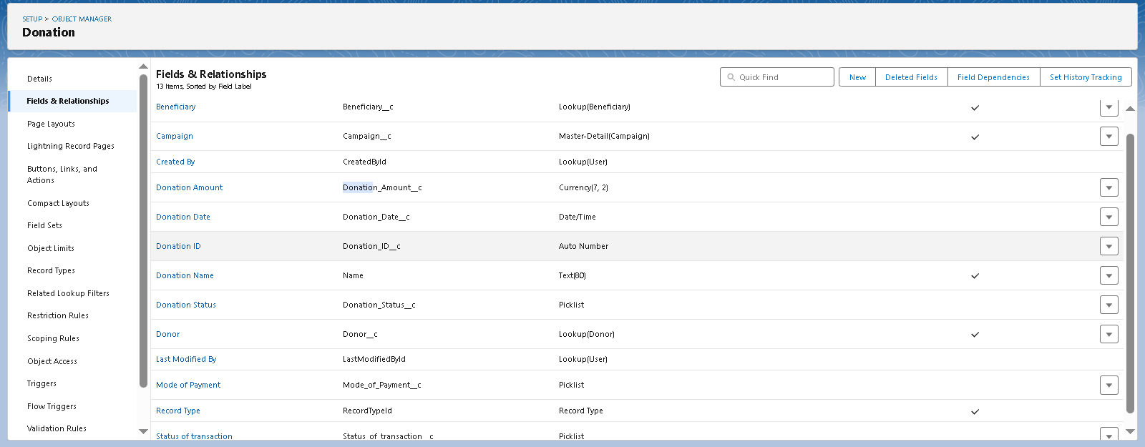

### Impact Cart Object

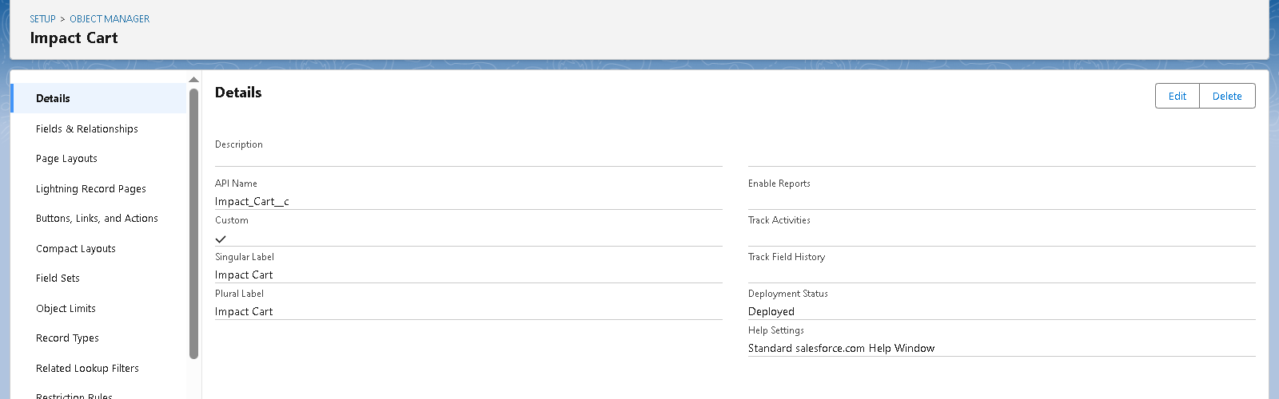 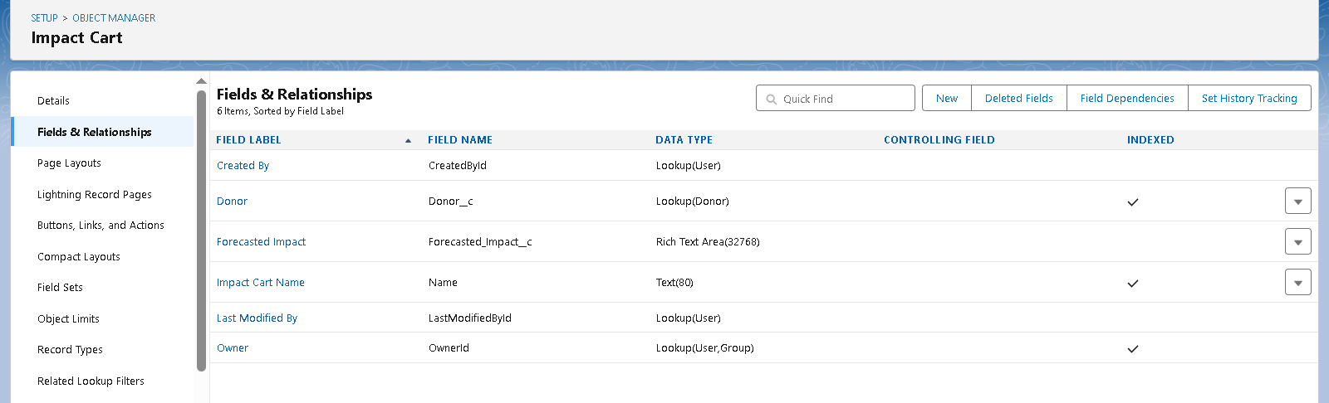

### Schema Bulder

